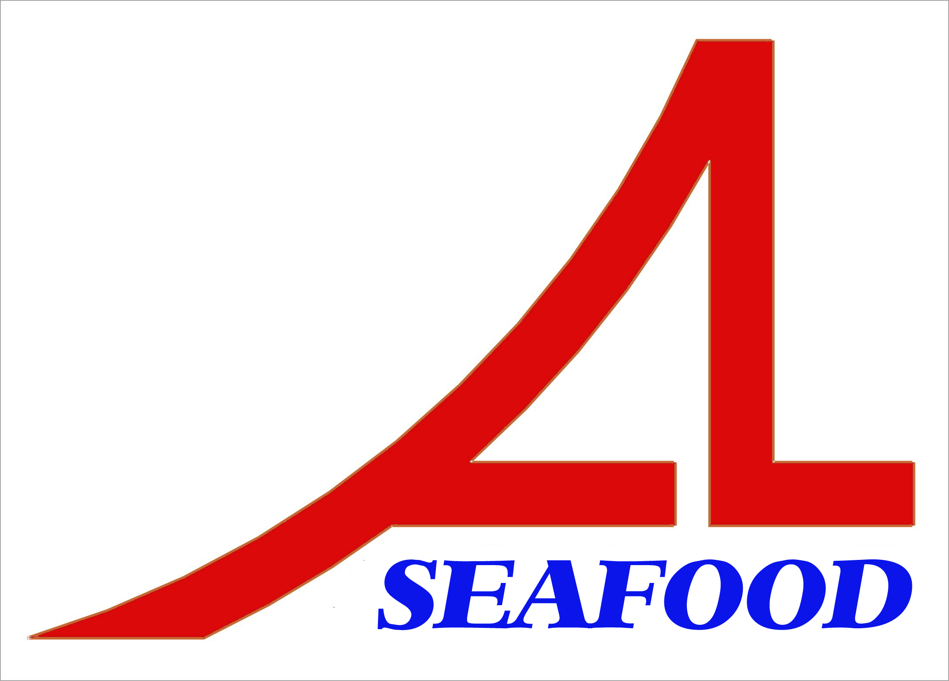AN LAC SEAFOOD CO., LTD.

Lot A14, 4A Street, Hai Son Industrial Zone, Duc Hoa District, Long An Province, Vietnam.
* E-mail: longan@anlacseafoods.com * Website: www.anlacseafood.com

* Tel : 84-72-3850606 * Fax : 84-72-3850608

OFFER SHEET

Date: OCT. 18, 2017.

To: HEACHEONG FOOD CO., LTD
457, MANGYANG - RO, YEOSU - SI, JEOLLANAM-DO, SOUTH KOREA

We would like to offer you the products by our company with terms and conditions as follows:

1/ GOODS:

No. | DESCRIPTION OF GOODS | QUANTITY (KGS) | UNIT PRICE  CFR PORT  (USD/KG) | AMOUNT (USD)
1 | DRIED SEASONED FLATHEAD FISH | 12,000 | 8.20 | 98,400.00
TOTAL |  | 12,000 |  | 98,400.00
SAY: US DOLLARS NINETY EIGHT THOUSAND FOUR HUNDRED ONLY. (CFR PORT, KOREA)

2/ SHIPMENTS : 30 days after receiving L/C at sight
3/ PAYMENT :
By irrevocable L/C at sight into account of the seller’s No.: 101000268614 at VIETNAM PUBLIC JOINT STOCK COMMERCIAL BANK – GIA DINH BRANCH
Address: 495 - 497an Duong Vuong Street, Ward 08, District 05, Hochiminh City, Vietnam.
Swift. WBVNVNVX

BENEFICARY: AN LAC SEAFOOD CO., LTD.

Valid: Nov. 03, 2017

Looking from and to your early reply.

Thanks and best regards

AN LAC SEAFOOD CO., LTD

DIRECTOR

